Insurance data : First 5
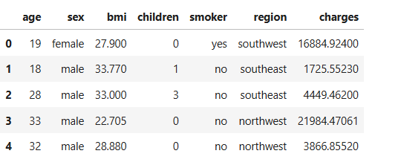
Southeast has the highest total charges (€5.3M) AND the highest average charge per customer (€14,735). This region is the most expensive
Northeast is second highest in average charge (€13,406) despite having fewer customers than the other regions
Northwest and Southwest are quite similar in both customer count and charges. The cheapest regions overall
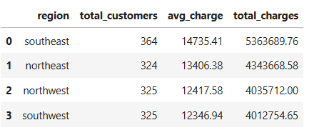
Why is Southeast so much more expensive than the others? What could be the cause?

Smokers pay on average €32,050 nearly 4x more than non-smokers!
Non-smokers pay on average just €8,434
Interestingly, the BMI is almost identical between both groups (30.71 vs 30.65) so BMI alone doesn't explain the difference, smoking does
The max charge for a smoker is €63,770 vs €36,910 for a non-smoker

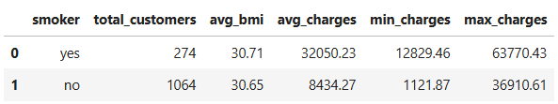

A customer with $1,121 in charges - cheap customer, low risk
A customer with $63,770 in charges - very expensive customer, high risk
Lets figure out more …. Which customers are likely to cost more?

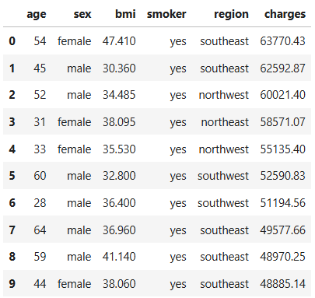
Every single one of them is a smoker
Southeast dominates
Most of them have high BMI
Mixed ages – so age alone isnt the factor
Smoking is by far the biggest driver of high insurance costs, especially when combined with high BMI and living in the southeast region

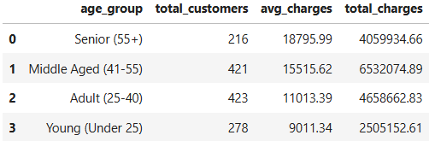
- Seniors (55+) have the highest average charges at $18,795 - older people need more medical care
- Middle Aged (41-55) are second at $15,515
- Adults (25-40) pay $11,013 on average
- Young (Under 25) are cheapest at just $9,011
So, as age goes up, charges go up almost perfectly age is a clear and steady driver of insurance costs!

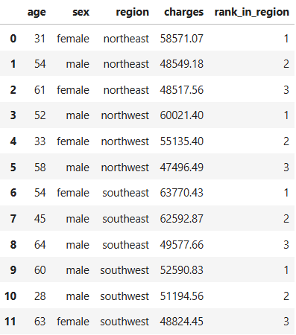

Southeast's #1 most expensive customer costs $63,770 - the highest of all regions
Every region's top 3 are all above $47,000 - consistent pattern across regions
Notice the 28-year-old male in southwest at $51,194 - very young but extremely high charges, almost certainly a smoker with high BMI

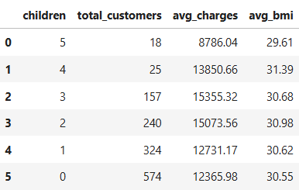
People with 1-3 children have the highest average charges (~$13,000-$15,000)
People with 0 children pay less on average ($12,365)
People with 5 children have surprisingly low charges ($8,786) but only 18 customers, so too small a sample to draw conclusions
BMI stays fairly consistent across all groups (~30) - children don't affect BMI

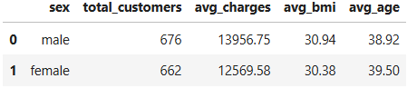
No big difference to take from this

Final profile :
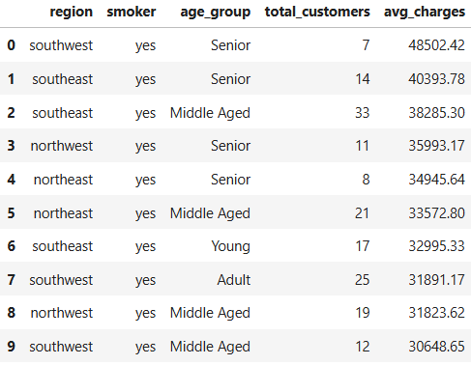

Every single row shows they are a smoker : That’s no exception!!!
Senior smokers in southwest are the most expensive at $48,502 average
Southeast smokers appear 3 times in the top 10 - consistently the most expensive region
Even young smokers in southeast cost $32,995 - smoking overrides the age advantage completely
The Business insight to take away from this is :
Smoking is the single biggest risk factor for high insurance charges, regardless of the age, region or gender

